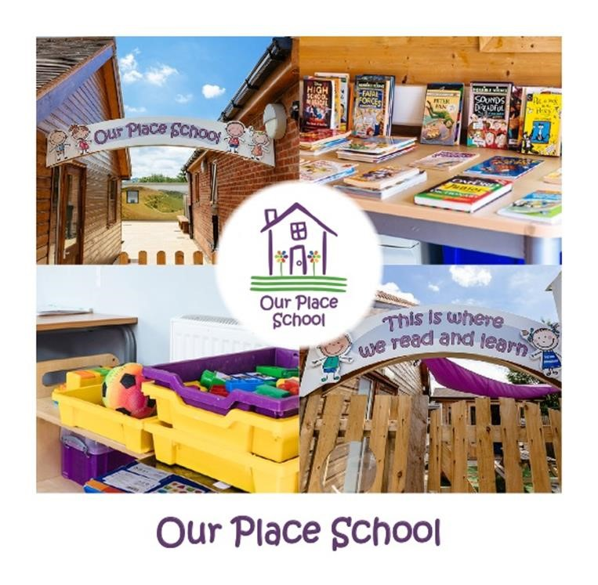
EDUCATION
SEND Policy
Policy  Number | Version | Date | Policy Owner | Review Frequency | Review Date
ED 16 | 4 | June 2022 | Lauren Tallis | Annual | June 2023
Table of Contents
Section | Item |  | Page
1 | Policy Statement |  | 4
2 | About Our Place Schools |  | 4
3 | Admission of Students |  | 5
4 | Policy Aims |  | 5
5 | Policy Objectives |  | 5
6 | Meeting the Policy Objectives |  | 6
7 | Our Approach to Teaching Students with SEND |  | 6
8 | School Staffing |  | 7
9 | Moving on from Our Place Schools |  | 7
10 | Monitoring and Evaluation Arrangements |  | 7
11 | Complaints and Concerns |  | 8
12 | Other Relevant Policies |  | 8
Approved by |  | Name | Date
Head of Education |  | Lauren Tallis | June 2022
SENCO |  | Ali Price | June 2022
Education Review Board |  |  | June 2022
Review Sheet
The information in the table below provides details of this document’s reviews and where appropriate, amendments which will have been made to a later version and the reason.
Version | Review Description | Date
1 | Original | May 2019
2 | Updated to reflect standards and put in new Policy format | Dec 2020
3 | Reviewed and updated | Dec 2021
4 | Reviewed to reflect changes in OPG Leadership & Proprietor | June 22

SEND Policy

1. Policy Statement
This policy complies with the statutory requirement laid out in the SEND Code of Practice 0 – 25 years.
At Our Place Schools, we use the definition for Special Educational Needs and Disability (SEND) from the SEND Code of Practice (2014). These definitions are:
- SEN: A child or young person has special educational needs if he or she has a learning difficulty or disability which calls for special educational provision to be made for him or her.
- A learning difficulty or disability is a significantly greater difficulty in learning than the majority of others of the same age.
- Disability: Many children and young people who have SEN may have a disability under the Equality Act 2010 – that is ‘…a physical or mental impairment which has a long-term and substantial adverse effect on their ability to carry out normal day-to-day activities.’
2. About Our Place Schools

Our Place Schools Vision Statement
Opportunity Potential Safety
Our Vision statement ‘Opportunity, Potential, Safety’ reflects our understanding and beliefs.
We believe every child deserves to feel safe and secure, receive an excellent quality of care and education and the chance to fulfil their potential, whatever their background or needs.
Children who are Looked After, deserve these opportunities too.
  - Our Place School is situated on the outskirts of west Worcester towards Malvern, near the village of Bransford, in a rural location with large open spaces and extensive grounds. The school is an independent special school, for students aged 8 - 19 years. The school offers an education for students with an Education Health Care Plan (EHCP) and a diagnosis of Autistic Spectrum Disorders (ASD).
1.2 School Provision
The school offers bespoke learning based on the needs of the children and young people. The team comprises:
Head of Education – Lauren Tallis
Deputy Head/SENCO- Ali Price
Assistant Heads – Nikki Doughty, Kathryn Childs
Teachers- Mark Moloney, Martine Slim, Huw Burton, Courtney Mcllroy, Sean Earlam

3. Admission of Students
Students are admitted to the school following statutory referral and assessment procedures.
The referring authority will always involve parents and carers whenever possible throughout this process and opinions will be sought about the most appropriate school for their child.
Students are offered a place at the school when indicated on their ‘Education, Health and Care Plan’ (EHCP) or agreed by all relevant parties. The team assessing new students will keep in mind the wellbeing of the existing cohort of students, whilst ensuring that the school meets its responsibilities under the Equality Act 2010 with regard to reasonable adjustments and access arrangements for any potential new admission.
We will have an early discussion with the student, parents and carers about how life at Our Place School is for the young people and how their SEND changes the support we can offer and our aspirations for them.

4. Policy Aims
- To give our students a positive school environment in which they feel safe and can have confidence in their abilities.
- To provide a curriculum that meets the student needs.
- To consider each student as an individual and work in cooperation with appropriate outside agencies and authorities to identify student needs and ensure the needs are met in conjunction with plans.
- To engage with students at their appropriate level, and give opportunities to communicate and interact.
- To ensure a high level of staff expertise is available to meet student need, through well targeted continuing professional development, and cooperative working between the home and school.
- To encourage students to adopt a healthy lifestyle both physically and emotionally.
- To work with students, families and local authorities in supporting students moving on from Our Place School.

5. Policy Objectives
- To provide information on how we identify and assess SEND of the students.
- To provide support and advice for all staff working with students with special educational needs.
- To work in partnership with students, parents, carers, schools, and external agencies.
- To provide a Special Educational Needs Co-ordinator (SENCO) who will work to ensure that the SEND Policy is fully embedded.
- To outline provision for SEND students.
- To explain the roles and responsibilities of everyone involved with SEND students.
- To work within the guidance provided in the SEND Code of Practice, 2014

6. Meeting the Policy Objectives
All students at Our Place School have an Education, Health and Care Plan (EHCP) and part of the statutory transition to Our Place School requires that students needs identified in the plan are considered and at this time a full assessment is completed by appropriate professionals to ensure that the needs of the student can be met by Our Place School, and that any changes are noted as part of the EHCP review.
The needs of the students are continually reviewed by school staff, and visiting professionals, with a formal review of documentation through statutory meetings.
The SEND requirements of our students are met through classrooms customised around their needs or if appropriate pairs of students with similar SEND that are most appropriately taught in that setting.
The students have a curriculum planned to meet their individual needs, further information on this can be found in the Curriculum Policy. Staff trained in the ‘Thrive Approach’ support young people with their emotional health, wellbeing and social skills, all of which are needed to enable learning to take place.
Young people cannot always tell us how they are feeling, however, the way they behave can tell us a lot about how they are feeling, and additional information on the Thrive Approach can also be found in the Curriculum Policy.
The views of the parents and carers of students are sought regularly, both informally via email, over the phone or at family contact sessions, and formally during statutory meetings associated with the EHCP. Regular review and dialogue of the plan and progress being made helps the school to ensure the students needs are met and they are satisfied with the SEND adjustments Our Place School makes.
Parental views can also be submitted via the Our Place School website directly to Ofsted using the
Parent View Your Child’s School Link, or via the web address: https://parentview.ofsted.gov.uk/

7. Our approach to teaching students with SEND
- Teachers are responsible and accountable for the progress and development of all the students in their classes.
- High quality teaching is our first step in responding to students who have SEN. This will be highly differentiated according to need.
- Further details of our approaches can be found in the school Curriculum Policy.
- There is consistency and flexibility within the school staffing structure which allows student’s needs to be met effectively.
Our Place School will work in partnership with external consultants in areas including:
- Occupational Therapy
- Speech and Language Therapy
- Psychology
- Psychiatry
- Advocacy
- Multi Sensory Impairment
- Applied Behavioural Analyst
The level of student need will determine the level of engagement from agencies.

8. School Staffing
Teaching and learning staff:
The teachers and teaching assistants at Our Place School will ask the school Senior Leadership Team (including SENCO) any questions they have regarding SEND and can request additional training of specific areas of SEND as a need arises.
Our Place School will provide continued professional development (CPD) covering areas of SEND, and liaise with teachers and teaching assistants to ensure their training needs are met. Teachers and teaching assistants will as part of their CPD have opportunities to visit other schools.
SENCO
The named SENCO at Our Place School:- Ali Price
- Will have day-to-day responsibility for adherence to the SEND policy and the co-ordination of provision and its quality, made to individual students;
- Continually works with all Our Place Schools staff and Education Review Board to determine the strategic development of the SEND policy and ensure it is fit for purpose;
- Provides professional guidance to colleagues and works with staff, parents, and other agencies to ensure that students with SEN receive appropriate support and high-quality teaching;
- Will be the point of contact for external agencies, including the multidisciplinary team, the local authority and its support services;
- Liaises with potential next step providers of education to ensure students and their parents are informed and transitions are well planned;
- Ensures the school keeps the records of all students with SEN up to date in accordance with GDPR Policy and;
- Monitors that the interventions are recorded in line with the provision mapping needs of the placing local authorities (where necessary), and reviewed as part of a timely ‘assess, plan, do and review’ cycle.

9. Moving on from Our Place Schools
We will share information with the school, college, or other setting the student is moving to. We will agree with parents and students which information will be shared as part of this. Students with EHCPs are entitled to remain in full time education until the end of the school year in which they are 19. The decision as to when it is most appropriate for a student to leave is made through the review process.

10. Monitoring and Evaluation Arrangements
This SEND policy will be reviewed annually by the Our Place School Senior Leadership Team. It will also be updated in light of any changes made during the year.
The effectiveness of the SEND Policy will be review annually after all students EHCP and Personal Education Plans have been completed for the academic year.
Our Place School will use parental and local authority feedback in all meetings to ensure adherence to the policy.
At Our Place School the success of the SEND Policy will be judged on student wellbeing and progress in term of EHCP outcomes.

11. Complaints and Concerns
There may be occasions where a parent or carer may feel the need to raise a concern or to make a complaint about the special educational provision made for their child at Our Place Schools.
Further information is available in the Complaints Procedure Policy.
In line with the Complaints Procedure Policy, the information is acted on quickly and the person raising the complaint should be contacted by a member of the Senior leadership Team within 24 hours.
Further information on SEN and disability statute law, regulations and guidance can be found on the Independent Parental Special Education Advice (known as IPSEA) website at:
https://www.ipsea.org.uk/sen-and-disability-statute-law-regulations-and-guidance

12. Other Relevant Policies
The SEND Policy relates to several policies that can be found on the Our Place Schools website.
The policy directly references:
- Curriculum Policy
- Complaints Procedure Policy
- GDPR

