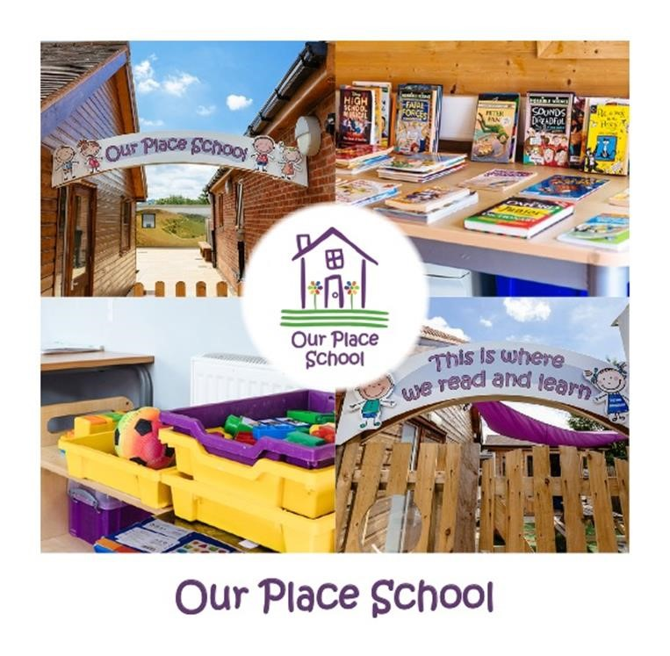
EDUCATION

Admissions Policy

ADMISSIONS POLICY

Policy No | Version | Date | Policy Owner | Review  Frequency | Review Date
OPG | 3 | Oct 2022 | Lauren Tallis | Annually | Oct 2023

Section | Item | Page
1 | Policy statement | 4
2 | Initial enquiries and referrals | 4
3 | The placement assessment | 4
4 | Funding arrangements | 5
5 | Preparation for placement | 5
6 | Review of placement (residential) | 5
7 | Review of placement (education only) | 5
8 | Placement refusal or termination | 5

Approved by | Name | Date
Head of Education | Lauren Tallis | Oct 2022
Education Review Board |  | Oct 22

Review Sheet
The information in the table below provides details of this document’s reviews and where appropriate, amendments which will have been made to a later version and the reason.
Version | Review Description | Date
1 | New policy to incorporate day provision | 09/2021
2 | Updated to reflect changes in Our Place Group | 07/2022
3 | Updated to reflect cancellation of The Orchard care home | 10/2022

Admissions Policy

1. Policy Statement
A student’s education is one of the most important parts of their life, and at Our Place School we endeavour to ensure students have access to a robust and well-rounded curriculum which is tailored to meet the needs of each individual student.

This policy outlines the school’s procedures for admissions. Our Place School aims to promote the Opportunity, Potential and Safety for all student’s. As noted in our mission statement “We believe that every young person deserves to feel safe and secure, receive an excellent education and the chance to fulfil their potential, whatever their background or needs.” Given our aims we seek not to have a narrow or specific admissions criteria. Instead, our approach to accepting admissions involves ascertaining a student’s individual needs and aspirations to ensure we can provide the best educational and care service to meet requirements, whilst ensuring that all students can be kept safe.

Our Place School is fully committed to equality, diversity and inclusion of all students and staff. This policy has due regard to all relevant legislation and guidance including, but not limited to, the following:
- Education Act 1996
- The Education (Independent School Standards) Regulations 2014
- The Education (Pupil Registration) (England) Regulations 2006
- Equality Act 2010
- Robert Long (2019) “Independent Schools (England) (Briefing Paper)”
- DfE (2019) “The Independent Schools Standards”

2. Initial Enquiries and Referrals
Initial enquiries and referrals are accepted from individuals as well as Local Authority or West Midlands Placement Portal. We are also on the CRAGG database and have direct referrals too. Enquiries and referrals are welcomed all year round.
Our Place School only admits students with an Education Health and Care Plan as well as a confirmed diagnosis of Autism Spectrum Disorder.
Our Place School will request basic information (which must include a copy of the most recent EHCP) about the student and, at this point, information about the school and care provision will be provided.
If the referral documentation indicates that a young person’s needs could be met by Our Place School, the Headteacher will respond to parents/carers and the Local Authority as required, e.g. completion of an expression of interest form, consultation form or otherwise respond confirming a full assessment of the young person’s needs will be undertaken, as well as inviting the student’s representatives for a visit to school.

3. The placement assessment
Following the visit, if Our Place School is considered a suitable educational placement and an official request to place is received, Our Place School will arrange to send representatives to visit the student in their current setting.
The placement assessment will be used to determine if Our Place School believe it is able to meet the young person’s needs, based on the presenting information.
The placement assessment will also be used to determine the level of funding we believe is required to fully meet the student’s needs. The visit will inform ongoing arrangements for the potential transition of the student into school.

The school makes no charge for assessment visits.

4. Funding Arrangements
The majority of places for young people at Our Place School are commissioned. Priority for commissioned places will be based on confirmation of funding and placement from the Local Authority as well as the current numbers of students at Our Place School.
Confirmation of a placement is subject to the available high needs funding from the placing Local authority and whether the funding is sufficient to then meet the identified needs of the individual based on that funding.

For residential placements, Our Place Group accepts referrals from any Local Authority in England and Wales.

For Education only placements, Our Place School will only accept referrals from the authorities which are local to our school due to the transition times and distances.

5. Preparation for Placement
Once a placement has been confirmed, a placement start date and transition process will be agreed. Close contact will be maintained with parents/carers to ensure they are fully involved in the transition and can ask any questions as they arise. The transition plan will take on board the emotional impact of the student settling into a new school and/or home, their special education needs, and the pace of transition required.

6. Review of Placement (Residential)
For more information on placement monitoring for residential provision please see Central Function Admissions Policy.

7. Review of Placement (Education only)
A review of the education placement will take place within six weeks of the placement commencing, which will form part of the change of provision for the EHCP.
This review will be used to share information from initial assessments and to establish current learning goals and planned outcomes for the young person. At this stage, we will determine the pathway and destination ends to ensure that the programme of study is suitable to help the young person achieve this. Following this, there will be an Annual Review of the Education, Health, and Care Plan, as well as termly education or PEP meetings – in lined with the recommendations from the SEN Code of Practice.

8. Placement Refusal or termination
Our Place School reserves the right to not offer a place to a young person where we believe our provisions cannot meet the needs of any one individual based on current information presented in the EHCP and/or as part of our assessment process, where we believe that the welfare, health and safety of the school’s students or staff could not be maintained.
If the school determines that it can no longer meet the needs of a young person, or that the young person is having an adverse effect on the learning or welfare of others then a review of placement may be necessary. For more information on this please see our Exclusion Policy.

