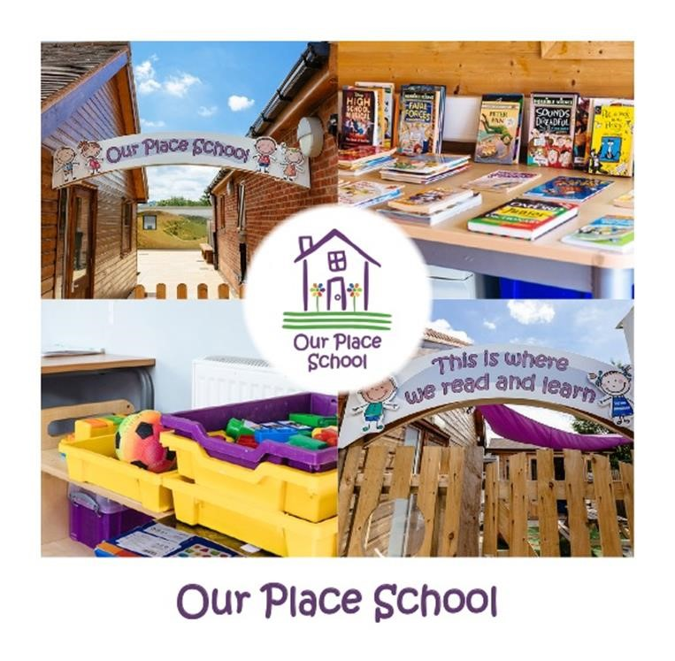

EDUCATION

Accessibility Policy and Plan

Policy Number | Version | Date | Policy Owner | Review Frequency | Review Date
ED 8 | 4 | November 2022 | Lauren Tallis | Annually | November 2023

Table of Contents

Section | Item | Page
1 | Introduction | 4
2 | Legislation and Guidance | 4
3 | The Planning Duty | 4
4 | The Accessibility Plan (2022- 2024) | 5
5 | Monitoring and Review | 5
6 | Other Relevant Documents | 5
 | Appendix 1 Accessibility Plan 2022- 2024 | 6

Approved by | Name | Date
Headteacher | Lauren Tallis | Nov 2022
Education Review Board |  | Nov 2022

Review Sheet
The information in the table below provides details of this document’s reviews and where appropriate, amendments which will have been made to a later version and the reason.

Version | Review Description | Date
1 | Original Policy | 2019
2 | Updated | June 2020
3 | Updated | May 2021
4 | Updated | May 2022
5 | Updated to reflect changes in the Our Place Group | November 2022

Accessibility Policy and Plan

Introduction
Schools are required under the Equality Act 2010 to have an Accessibility Plan. The purpose of the plan is:
  - To maximise participation in an accessible curriculum
  - To continually improve the physical environment to maximise access
  - Improve the availability of accessible information for all.
Our Place School aims for all students to enjoy learning, make progress and achieve, to become confident individuals living safe, healthy and fulfilling lives, who are included and treated no less favorably than any other member of society in accessing services. The school’s aim is for students to:
- Engage in Learning
- Develop communication skills
- Develop resilience
- Form positive relationships
- To be fully included in all aspects of school life

Legislation and Guidance
This document meets the requirements of schedule 10 of the Equality Act 2010 and the Department for Education guidance for schools on the Equality Act 2010.
The Equality Act 2010 defines an individual as disabled if they have a physical or mental impairment that has a ‘substantial’ and ‘long-term’ adverse effect on his or her ability to undertake normal day to day activities.
The Special Educational Needs and Disability (SEND) Code of Practice defines ‘long term’ as ‘a year or more’. The definition includes sensory impairments such as those affecting sight or hearing, and long- term health conditions such as asthma, diabetes, epilepsy and cancer.
This policy has due regard to all relevant legislation and statutory guidance including, but not limited to:
- Human Rights Act 1998
- The Special Educational Needs and Disability Regulations 2014
- Education and Inspections Act 2006
- Equality Act 2010
- Education Act 1996
- Children and Families Act 2014
- The Equality Act 2010 (Specific Duties and Public Authorities) Regulations 2017
- DfE (2014) ‘The Equality Act 2010 and schools’
- DfE (2015) ‘Special educational needs and disability code of practice: 0 to 25 years’

The Planning Duty
The Act places a duty (the Planning Duty) on schools to prepare Accessibility Plans for:
- Increasing the extent to which students can participate in the school curriculum, e.g. leisure activities and school visits.
- Improving the physical environment of schools to increase the extent to which disabled students can take advantage of education and associated services.
- Improving the delivery of written information, e.g. handouts, timetables etc.
As an Independent school we will make our Accessibility Plans available to interested parties on request at reasonable times.

The Accessibility Plan (2022-2024)
This plan aims to improve access to all aspects of education within Our Place School and is organised in a way that helps to remove existing barriers to student learning. It also aims to widen the opportunities available to students who may have had restricted access to the wider community in previous settings.
This plan incorporates aspects of The Thrive Approach in creating a specific way of working with all children that help them develop their social and emotional wellbeing, enabling them to engage with life and learning. It supports them in becoming more self-assured, capable and adaptable. It can also address any troubling behaviours providing a firm foundation for academic attainment.

The SLT will undertake an annual accessibility audit, and in collaboration with the Education Review Board and teaching team will identify areas split into the following categories:
- Access to the curriculum –to assess the extent to which students with disabilities can access the curriculum on an equal basis with their peers.
- Access to the physical environment – to assess the extent to which students with disabilities can access the physical environment on an equal basis with their peers.
- Access to information – to assess the extent to which students with disabilities can access information on an equal basis with their peers.
When conducting the audit, all kinds of disabilities and impairments will be considered, including, but not limited to, the following:
- Ambulatory disabilities – this includes students who use a wheelchair or mobility aid
- Dexterity disabilities – this includes those whose everyday manual handling of objects and fixtures may be impaired
- Visual disabilities – this includes those with visual impairments and sensitivities
- Auditory disabilities – this includes those with hearing impairments and sensitivities
- Comprehension – this includes hidden disabilities, such as autism and dyslexia
The findings from the audit will be used to identify short-, medium- and long-term actions to address specific gaps and improve access, whilst also taking into account that we are a Special School with a highly bespoke curriculum and environment.

Monitoring and Review
Our Place School will monitor the implementation of the plan and regularly review the access needs of the school in several ways:
- Feedback from our students themselves.
- Observation and assessment of our student’s engagement levels.
- By monitoring the self-esteem of students and staff.
- Achievement of outcomes set for individual students.
- Student progress.
- Lesson observations.
- Networking with other providers.
- Engaging positively with regulators
- Feedback from our staff, parents, Social Workers, Virtual School Teachers, LA representatives etc.
- At least six Monitoring Visits (announced and unannounced) over the course of an academic year, with subsequent reports - made by the SLT/Education Review Board/external parties.
- Work scrutiny.
- Planning.

Other Relevant Documents
Accessibility planning should be considered in conjunction with the following policy and strategy documents:
  - Curriculum policy
  - Equal opportunities policy
  - Health and safety policy
  - SEND policy
  - Behaviour Policy
  - Child-on-child abuse policy
  - School Development Plan

Appendix 1
Accessibility Plan 2022-2024

Accessibility Plan Aim | Accessibility Code
To maximise participation in an accessible curriculum | C
To continually improve the physical environment to maximise access | E
Improve the availability of accessible information for all. | I

Objective | Accessibility Code | Current good practice | Actions to be taken | Person responsible | Completion Date
To improve  provision for  students with  SEND. | C, I | Our school  offers a  differentiated  curriculum for  all students. We  use resources  tailored to the  needs of our  students to help  reduce their  barriers to  education. | To embed the  Thrive approach/PACE  and ABA to further  enhance the  effectiveness of  our provision. | HT, SLT,  Teachers and  TA’s. | 2023
To develop the natural and spontaneous communication skills of our students. | C, I | We are beginning to use the Attention Autism learning approach to improve joint attention, develop shared enjoyment in group activities and increase the attention and focus for our students. | Create opportunities for all students to engage in the Attention Autism programme., | KC (AHT), Teachers and TA’s. | June 2023
To ensure transitions are as settled as possible for our day students | E | Due to transitions being particularly challenging for two of our students we have made the decision to use our drivers and vehicles instead of the transport to reduce anxieties. | Liaising closely with the transport teams at Hereford, Solihull & Worcester to ensure that transport is sorted asap for our new admissions. | HT, SLT, Central services | Feb 2023.

Objective | Accessibility Code | Current good practice | Actions to be taken | Person responsible | Completion Date
To improve the  progress for  children with  communication  and language  Difficulties using a range of communication aids and devices. | C, I | Students and staff  have access to  Widgit Online  subscription to  enable the use of  pictorial or symbolic  representations of  words. We also use  a Total  Communication  Approach which  includes  MAKATON, and  individualised  communication  systems. | To enhance staff  skills in the Total  Communication  Approach  with support  from the newly appointed SALT. For the SaLT to model good practice and interventions to increase the use of effective communication within school.  Staff to complete Makaton training (introduction or revision). | HT, AHT,  Teachers  and TA’s.  SaLT,  External  ABA  consultant. | Spring 2023
To ensure the students feel safe and secure in their learning environment with reduced barriers to learning | C, E | During the assessment and admission process the learning environment is discussed to ensure we can offer the best possible learning experience for our young people. Any necessary purchases are made prior to admission. If needed, we will accommodate any classroom changes to increase engagement. | Audits to be compiled to take stock of all resources, furniture, sensory toys to ensure we have knowledge of what we already have or what we would need to buy for new admissions. | HT, AHT, Teachers | End of Spring term

