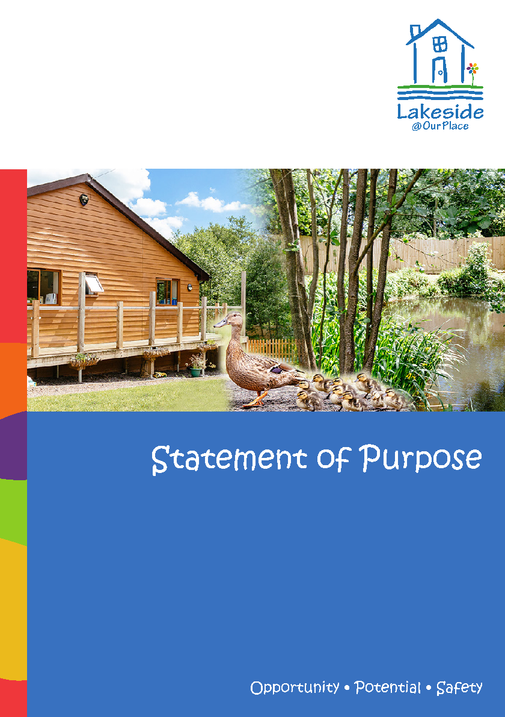
Residential Care Guide | Month 2022

Contents
Welcome to Lakeside @ Our Place 2
Our Aim 2
Our Objective 2
Our Vision Statement 2
Our Ethos 2
Overall Outcomes 3
The Home 3
Protection of Vulnerable Young People 4
Policies 5
Religious & Cultural Observance 5
Views, Wishes & Feelings 5
Enjoyment & Achievement 6
Anti-discriminatory Practice & Young People’s Rights 6
Education 7
Health 7
Positive Relationships 8
Promoting Contact 9
Promoting Positive Behaviour 9
Therapies 10
Meet the Multi-Disciplinary Team 11
Leadership & Management 12
Our Place Organisation Chart 13
Lakeside Leadership Team 14
Staff 13
Placement & Admissions 15
Emergency Placements 16
Complaints & Concerns 16
How to find us 17
Annex A XX

Welcome to Lakeside at Our Place
Lakeside at Our Place provides care and support for up to ten young people providing they have an EHCP and are engaged in education and for the purpose of independence. Lakeside accommodates both males and females, the service aims to move young people into adulthood who have special needs, moderate to severe learning difficulties, autism and challenging behaviours.

Our Aim
Lakeside at Our Place supports young people through adolescence and into adulthood. This is achieved through education and life skills development. Effective planning for the transitioning of young people to a successful adult provision, providing step down programmes of reduced support, where possible, with the hope of living a more independent life. Lakeside at Our Place will aim to support young people to achieve their ambitions and reach their best potential.

Our Objective
This will be achieved within a multitude of ways; the right of choice, individuality and developing positive, appropriate relationships within the community. Lakeside at Our Place provides well-tailored individualised plans for all young people, focusing on holistic support and care by working in partnership with both internal and external professionals and networks that the young people have.

Lakeside at Our Place has access to the onsite educational facility; however, we can support with transport to education facilities.

As well as Education, we do offer bespoke ‘Support for Learning’ packages which are outlined in Promoting Independence skills. We deliver an ASDAN qualification in independence to support young people to reach their potential.

Our Vision Statement
Our vision is the promotion of growth into adulthood porting Independence with Respect, Dignity and Equality. We want all young people to be successful and achieve their potential.

Our Ethos
Our Ethos at Lakeside at Our Place is to enable young people to develop independence skills, to strive to meet their full potential, with a person-centred approach, development within confidence and self -esteem to live as independently as possible. Young people will be provided a safe, nurturing environment where their skill sets, and outcomes are at their maximum potential.

Overall Outcomes
The overall aim of Lakeside at Our Place is to provide high-quality care and develop integrated life skills and offsite educational opportunities to enable young people to achieve their best outcomes alongside focusing on developing the young people’s; abilities, skills, and interests to live as independently as possible.

Our objectives are to develop independence based on ability and future liaise with other professionals.

• Cooking skills
• Self-care skill
• Ensuring that the young people can meet/ develop understanding of their health needs
• Have appropriate relationships in the community
• Manage/develop an understanding of their finances
• Develop self-regulatory strategies to promote management of their behaviour
• Employability and/or community inclusion
• Encourage young people to follow their aspirations and determine future goals

The Home
Lakeside at Our Place is a semi-rural, residential provision located in Bransford, Worcestershire and has been purpose built to provide young people with 10 private ensuite bedrooms. Lakeside provides placement for children and young people aged from 10-18 years. There are occasions where young people can remain accommodated at Lakeside past the age of 18, providing there are in fulltime education or transitioning to a new placement. The reason for this is that a placement move for a young person may cause disruption to their education. Each case is reviewed on an individual basis and should be reflected in the young person’s placement or pathway plan.

Rooms can be personalised by each young person’s tastes and each bedroom also has its own private postal address. The exterior of the home has large grounds to which the young people have day to day access and where they can plan activities which fit into their individualised plans.

There is a communal lounge area with a television and Internet accessibility. This provides a perfect opportunity for the young people to develop friendships, share interests and develop sharing and social skills.

There is access from the communal lounge to a balcony which overlooks a nearby lake. This can be used by our young people as long as supervision is present.

A fully fitted kitchen with all appliances and a dining area allows the young people to be supported in undertaking light kitchen duties to enable them to prepare meals and support their move to future independent adulthood.

We have wet rooms and access to a laundry room. Within the grounds of the home there is also a games room where the young people can have time to themselves to have some quiet time to relax and undertake activities of choice. There is also a sensory cabin which the young people can use to meet their sensory needs. Also in the grounds is a small quiet cabin that overlooks the pond which the young people can use for time of quiet contemplation.
In the grounds there is a suite of exercise equipment which the young people can use to keep themselves fit. There are also trampolines and swings to keep the children entertained. There is also plenty of room for outdoor games.
Protection of Vulnerable Young People
Safeguarding vulnerable young people is everyone’s responsibility. The health, safety and wellbeing of all young people within Lakeside at Our Place is of paramount importance to all adults who both work within and visit.

All young people have the right to protection, regardless of, age, gender, race, culture or disability.

All young people within Lakeside at Our Place are respected as individuals and are protected from harm. If there are safeguarding concerns for a young person, their placement plan, agreed between Lakeside @ Our Place, their placing authority and family/carers, this will include details of the steps that Lakeside @ Our Place will take to manage any assessed risks on a day-to-day basis.
Staff at Lakeside @ Our Place will continually and actively access the risks of each young person and the arrangement in place to protect the young people.

Lakeside @ Our Place staff will seek to protect the young people from harm and support them to manage their own safety when they are outside of the home. The staff team will have the skills and experience to enable the young people to stay safe away from Lakeside @ Our Place, this also includes the ability to identify the signs that a young person is at risk, and where necessary help the young person to manage the risks.

Lakeside @ Our Place has such safety features in place as; fob activated gates to the grounds. There also fobbed activated locks to the staff area and medication room. Each fob can be tailored to allow only access to certain individuals such as medication trained staff to the medication room. The COSHH, medication, sharps/ pantry and laundry room are locked by a key which is kept in the staff office, again in a lockable box. The main entrance is also on a fob activated lock at night. The young people will have access to these areas in relation to their assessed capacity and worked towards in relation to their set targets to minimise risks and ensuring the safety of the young people that reside at Lakeside at Our Place.

There will be a responsibility of all of the staff team at Lakeside at Our Place to take reasonable precautions and make informed professional judgements based upon the individual young person’s needs and developmental-stage about when to allow a young person to take a particular risk or follow a particular course of action, this will then be discussed with the young person’s placing authority and parents, where appropriate.

If a young person makes a choice that places them or someone else at significant risk or harm, Lakeside at Our Place staff will assist them to understand the risks and manage their own behaviour to keep them safe.

Young people will need to understand how to protect themselves appropriately, feel protected and be protected from significant harm. Lakeside at Our Place staff will encourage the young people who reside at Lakeside at Our Place to encourage young people to express their views about whether they feel safe, and if not why, both within and outside the home.

Staff will support the young people to understand how to ask for help to stay safe and that the home is an environment that supports this. A copy of the safeguarding policies can be obtained on the Lakeside at Our Place website or on request from the Registered Manager.

To ensure the safety of the young people that reside at Lakeside at Our Place there are surveillance cameras, placed on the outskirts of the building this is to monitor unauthorised visitors that may be present on the grounds. Staff in the home also use radio systems (walkie talkies) to communicate with each other. The grounds at Our Place Groups are vast and the homes are large, so communication between staff cannot always be verbally face to face.

Policies
Lakeside at Our Place policies can be accessed via the company website, which includes Lakeside at Our Place’s safeguarding and behaviour support policy, or alternatively a request to the Senior Management Team can be made for access.

Religious and Cultural Observance
Individual cultural and religious needs are supported and understood by the staff team in order to ensure that the young person is receiving culturally sensitive and appropriate care. This would be reflected in care plans, dietary requirements, opportunities for religious worship, personal items and hygiene and social arrangements during and before the admission process.

Views, Wishes and Feelings
Consultation - It is essential that the young people we care for have a voice and have a say in how the home is run. The individual young persons’ keyworker has an essential role in acting as their advocate and ensuring their views are heard. Each young person will take part in key worker sessions to obtain young person views wishes and feelings. The staff team will work with the young people to develop their independent skills, regularly reviewing their care plan and providing encouragement and support on how to achieve this will be part of these session including making sure that they are happy and feel safe.

The young people will be given the opportunity to participate in and shape the overall ethos, nature and routine of Lakeside at Our Place and given the relevant information, appropriate explanations and choices about daily life in the home and their wider plan of care. Each young person’s talents and interests will be understood and nurtured, with the young people developing confidence to select activities based on their personal preferences and abilities, so far as is reasonable.

Lakeside at Our Place will ensure that the young people are provided with the support, in line with their age and understanding to communicate their views, wishes and feelings and participate as much as possible in all aspects of their care planning and daily care.

The staff team have the skills and confidence to communicate easily and understand the importance of listening, involving and responding to the young people.

Staff have a responsibility to observe, notice and respond to the young people who are expressing their views and acknowledging that it is not the sole responsibility of the young person to initiate this communication.

The staff at Lakeside at Our Place play an important role in meetings, so as to support the young people and provide a clear understanding about their views, wishes, feelings and expectations for their future.

Enjoyment & Achievement

Each young person’s care plan will set out the permissions that their local authority has delegated to the registered person, this will outline the clarity of Lakeside at Our Place’s ability to give permission for offsite trips, involvement in sporting activities, leisure and cultural activities alongside any social integration with friends.

Lakeside at Our Place will, where possible, seek to identify and provide appropriate opportunities for all our young people that enable them to grow and develop as part of their individualised care plan. In addition, Lakeside at Our Place wherever possible will secure the appropriate authority to support and involve the young people in the same positive activities as their peers.

The young people at Lakeside at Our Place will be offered a wide range of opportunities and encouraged to participate in enjoyable and developmental activities such as: offsite trips, clubs, volunteering, and leisure activities.

Staff at Lakeside at Our Place will be skilled in understanding the range of influences that friendships can have and will encourage those with a positive impact and discourage those with a negative impact.
All of the young people who reside at Lakeside at Our Place will have access to local services and have the opportunity to participate in activities within the local community to enable engagement with the cultural, sporting, and leisure activities available to other young people in the community.

Anti-discriminatory Practice and Young People’s Rights
Staff at Lakeside at Our Place are committed to working with young people, in an anti-discriminatory manner and do not discriminate against any young people on any grounds.

In recognition that many of our young people have come from a multitude of backgrounds, we strive to provide an atmosphere where all young people feel safe enough to challenge anything that makes them unhappy or feel unsafe.

All young people are actively encouraged to make choices and decisions about their wishes and needs. All staff recognize this as the underpinning foundation of work they undertake with the young people at Lakeside at Our Place.

Education
Staff at Lakeside at Our Place are committed to working with young people, in an anti-discriminatory manner and do not discriminate against any young people on any grounds.

We have a school onsite which consideration can be given to provide a placement for young people who are placed at Lakeside.

Lakeside at Our Place has networked and created links within the local area and are constantly adding to these to be able to provide and support young people to achieve outside of the residential home. These links and activities include:

• Employability skills
• Support with creating CV
• Volunteering with the Canal Trust
• Charity shops
• Car garages
• Local college provisions (Worcestershire College, The Bridge and Horizons)
• Secondary Schools
• Apprenticeships (Car mechanics, chefs etc.)

Formal education can be sourced externally to the Lakeside provision, the young people, if required, will have support from Lakeside staff while at the external provision in which education is formally presented. We currently have links with The Heart of Worcestershire College, Our Place Schools, where the young people can have access to courses in line with their views, wishes and feelings, aspirations in line with their EHCP.

Health
Health Promotion
All young people have a Placement Plan which incorporates a full breakdown of their health needs and this is reviewed in consultation with the team, family and local authority with a focus on how they can support their own health needs.

This will include what support is required to enable best outcomes and how Lakeside at Our Place will deliver the model of care.

Each young person is registered with the local GP within 28 days of admission. They undertake routine dental, optical screening, and immunisations subject to the necessary consent from parents or the responsible individual.

The young people have access to the Learning Disability/CAMHS service and pathway through a referral from the GP. Further support from Lakeside at Our Place Therapy team will also be available for all areas including support with how to build young adult’s confidence and self-esteem for adulthood.

The staff at Lakeside at Our Place will support the young people to navigate to primary and secondary health services. The staff team will advocate on their behalf where necessary and appropriate alongside having a key role in organising and ensuring the young person’s attendance at these appointments and ensuring outcomes are followed. Lakeside at Our Place staff will encourage the young people to take a proactive role on the management of their day-to-day health and well-being and inform all other professionals and family members who also hold a responsibility for the young person’s health to seek to ensure each young person’s health needs are met.

If a young person has a specific health need, they will be supported by Lakeside at Our Place staff to manage these, subject to their understanding, in line with the young person’s placement plan. The young people will be offered advice, support and guidance on their health and personal care to support them to make informed choices whenever possible.

Lakeside at Our Place will play a key role in supporting young people to achieve and maintain a healthy lifestyle and ensure that the young people are provided with meals that are nutritious and subtitle for each young person. Young people will be involved in choosing and preparing meals and can sit as a group to eat their meals.

Positive Relationships
Lakeside at Our Place recognises that positive, stable relationships help the young person feel safe, secure and cared for.

Bullying can manifest itself in many forms such as behaviour by an individual group, repeated over time or intentionally hurting another individual/ group, physically or emotionally.

The wider access to technology has provided a new medium of bullying known as ‘cyber bullying’.
Lakeside at Our Place will work closely with the placing authority to understand the young person’s relationship history and staff working at Lakeside at Our Place will understand the appropriate level of contact with family and friends on initial assessment outlined within their care plan.

The home will liaise closely with health and educational professionals to ensure that outcomes identified, and progress made in relationship building and achieving socially acceptable behaviours.

Lakeside at Our Place will support to develop the young people’s understanding and empathy towards each other to enable the building positive relationships by having clear targets based on reducing socially unacceptable behaviour.

Positive behaviour and relationships will be praised and encouraged while poor behaviour will be discussed and supported to develop their skills to deal with conflict effectively, where necessary.

The staff at Lakeside at Our Place build constructive, warm relationships with the young people that actively promote positive behaviour which will provide the foundation for managing any negative behaviours.

Promoting Contact
Every effort will be made by the home to maintain the parent/child relationship.

All parents, social workers/local authority point of contact/ personal advisors and carers will be kept up to date with their young person’s progress through regular newsletters and monthly reports.

We encourage face to face contact at every opportunity. However, if this is not possible, we will encourage contact through internet access in a private area.

We will ensure that weekly summary is sent to parents and social worker along with pictures. The key worker will be available for phone calls at times convenient to both sides, and time will be made available for parents & family to speak to their child via any method preferred.

Promoting Positive Behaviour
We believe that majority of challenging behaviour is form of communications and potentially learnt behaviour to gain what a young people needs or wants.

As a team of specialists, we aim to give the young person a healthier and safer way to communicate, to gain there needs and wants.

Our aim is to discourage behaviours through:

• Individual My safety and support plans
• Teaching skills which will enhance self-image and self-esteem
• Providing positive role models rewarding positive behaviours
• Consistency of response
• Clear definitions of acceptable behaviour

Our Physical invention programme is through The Crisis Prevention Institute (formally known as MAPA)
, this is accredited by BILD.

In a case where a young person is causing significant harm to themselves, others or property and all proactive strategies outlined within their My safety and support plans have not worked, CPI trained staff would make a dynamic risk assessment to implement physical intervention in line the young person My safety and support plans.

This will be carried out in the best interests of the young person at the lowest level possible, to prevent further harm to themselves, others, or property.

As a part of staff induction an onsite, CPI trainer will deliver a 2 -day CPI course of the theory and practical physical intervention training. This is a comprehensive program where at the end of the program an exam is taken to ensure that there is a full understanding of CPI.

This is renewed annually, and regular practice sessions to ensure that when required this is safe and effective for the young person.

If any young person is involved in a physical intervention, a full debrief will be completed with the young people.

Some Young People maybe prescribed additional medication for behavioural reasons. Should a young person have behavioural PRN prescribed, instructions for use will be clearly documented within the young person’s plans, and a separate PRN protocol.

Therapies

Lakeside has access to the services of an experienced occupational therapist. We are currently recruiting a speech & language therapist. The young people also have access to a psychologist who is commissioned by Our Place group (post currently vacant). The young people can also access a range of services and therapies externally as required.
We use a number of other clinical based methods that are determined as best approaches for the young people, we thrive to fit practises around the children and not fit them into a particular model. Staff have training around nurturing and attachment (PACE) to help support the young people and understand their needs. We use an external trainer to provide monthly ‘team around the home’ meetings to understand the young people we are caring for and to review strategies.

All the young people will be assessed and provided services as appropriate. The multi-disciplinary team meet monthly to review the young people and develop the support strategies used by staff. They also provide guidance and training to staff on implementing these strategies.

All Therapists have the required qualifications and appropriate insurances. The therapists process a report and recommendation that are discussed with the senior management team and the direct care staff then put in to action. These are reviewed twice yearly by the therapist to measure the outcomes.

All reports will be shared with the placing authority, allocated social worker and where appropriate the parents or guardians.

Meet the Multi-disciplinary Team
The Multi-disciplinary team all meet regularly to review the therapeutic input, assessment, and the effectiveness of these recommendations and offer support to our children to ensure we meet their individual needs.

Speech and Language

Post vacant-Recruitment in process

Paediatric Nurse

Post vacant-Recruitment in process

Gopal Mehra - Occupational Therapist
Gopal has been working at The Orchard since June 2019 as a support worker whilst completing his BSc (hons) in Occupational Therapy. Working at The Orchard and supporting children with their complex needs has given him great opportunity to get to know them and build good relationships with them. This has given him great foundations to now support them with all their sensory needs.

Psychologist BSc(hons)

Post vacant-Recruitment in process

Leadership and Management

Registered Person’s Details-Chris Johnson

Chris has worked in residential services for 7 years and 10 years with vulnerable children and young people. Chris has practiced as a support worker, senior support worker and been a registered manager. Chris has a level 3 diploma and is working towards completing his level 5 diploma in leadership and management

Responsible Individual-Justine Bishop

Justine is a qualified social worker who has worked in social care for over 12 years. Justine has experience of managing residential homes, short breaks homes, care leavers service, Outreach team and a homeless intervention team.
Justine has a level 3 diploma and a level 5 diploma in leadership and management

Lakeside Organisation Chart
Executive Director

Responsible Individual

Lakeside

Registered Manager

Deputy Managers

Duty Manager

Support workers

Staff
The home is staffed in line with the agreed needs and funding requirements of the young people, which will be set out in 1-1 hours, shared care hours, independence, and night support.

All care staff receive a full induction programme including shadow shift before working directly with the young people. We also have a monthly training and development week every month, for mandatory and service targeted training.

All care staff who are not already qualified will be expected to undertake a ‘Level 3 Children’s Workforce Diploma’ after successful completion of a 6 monthly probationary period. In the event that a member of staff has an equivalent or higher qualification a level 3 unit top up, will be explored and the registered person will make the final decision on where this is appropriate.

Staff receive regular supervision in line with Our Place group policy.

All staff have an annual performance review in line with Our Place group policy.

All recruitment posts at Lakeside at Our Place are advertised and all applicants are subject to safer recruitment vetting and checks during the application process to ensure that it is fair and accessible to all from the local community.

Here at Lakeside you will always find a member of management available or on site, the leadership support also includes a senior member of the team on call 24 hours a day.

Placement and Admission
Lakeside at Our Place has the advantage of being able to offer young people the opportunity to access care, support and offsite education programmes, to support their steps into independence. We offer placements to young people aged 10 to 18 years old and older providing there are in full time education. Young people can be placed at Our Place up to a full 52- weeks placement.

We also offer flexible shared care to young people who do not require 52-week placements. We aim to be as flexible possible to ensure we meet the needs of young people and their families.

We will have clear plans for independence and robust assessments will take place to monitor and review progress.

Lakeside at Our Place can accommodate young people with special needs, moderate to severe learning difficulties, autism and challenging behaviours, with the ethos and culture of improving independence to enable young people to move onto supported living or independent facilities.

Once a young person has been referred to Lakeside at Our Place, the registered manager will coordinate the referral and assessment process; they will be the referrer’s point of contact.

An initial assessment will be carried by a senior staff member who will observe and gather information in the young person’s current setting.

Once all assessments have been completed, Lakeside at Our Place will provide the outcome of the assessment to the referrer, as we will need to ensure that Lakeside at Our Place can meet the statement of purpose’s objectives.

Emergency Placements
Lakeside at Our Place can consider emergency placements assuming that space is available, however the young people must meet the objective for the placement. The decision to admit will be based on the following;

• Whether young person can be accommodated
• They must meet the criteria set out in the Statement of Purpose
• Risk assessments
• The impact on any young person already accommodated at Lakeside at Our Place

The Senior Management Team will require current placement/care plan, risk assessment, health and wellbeing plans to include medical needs and current medication.

If after the outcome of an Emergency Placement meeting, we can meet the young person’s needs, suitable arrangements will be made to accommodate them.

Complaints and Concerns
Lakeside at Our Place is committed to providing the best care and independence programme, for each individual young person, but we also welcome any complaints or concerns from anyone relating to the child to be shared with Lakeside in line with pour policy. Any concerns or complaint will investigate with clear outcome for improvement.

If you are not happy with outcome of complaint you can contact the following:

Ofsted: You can make a complaint by letter: Ofsted, Clive House, 70 Petty France, London, SW1H 9EX. Email: enquiries@ofsted.gov.uk Tel: 0300 123 1231, or in person.

Children’s Commissioner: Anne Longfield OBE, Sanctuary Buildings, 20 Great Smith Street, London, SW1P 8BT Tel: 020 7783 8330.

DfE: Sanctuary Buildings, Great Smith Street, Westminster, London, SW1P 3BT. Tel: 0870 000 2288. Email: info@dcsf.gsi.gov.uk

You can contact Lakeside at Our Place on 01886 833378 for a copy of the complaints procedure to support you further.

How to find us
From M5: Leave the M5 at Junction 7 (signed Worcester, Evesham and A44. Join the A44 towards Worcester and at the roundabout, turn left onto the A4440. Remain on the A440 for approx 5 miles. At the fifth roundabout take the first exit onto the A4033 Remain on this road for approx 2 miles, you will come to an small island with the Bank House Hotel being on your left, take the second exit onto the A4033 follow this road for approx. a mile and you will see the Our Place sign on the left.

By Train: The nearest station is Malvern, Travelling time to Malvern from Worcester Foregate Street is approx. 10 mins

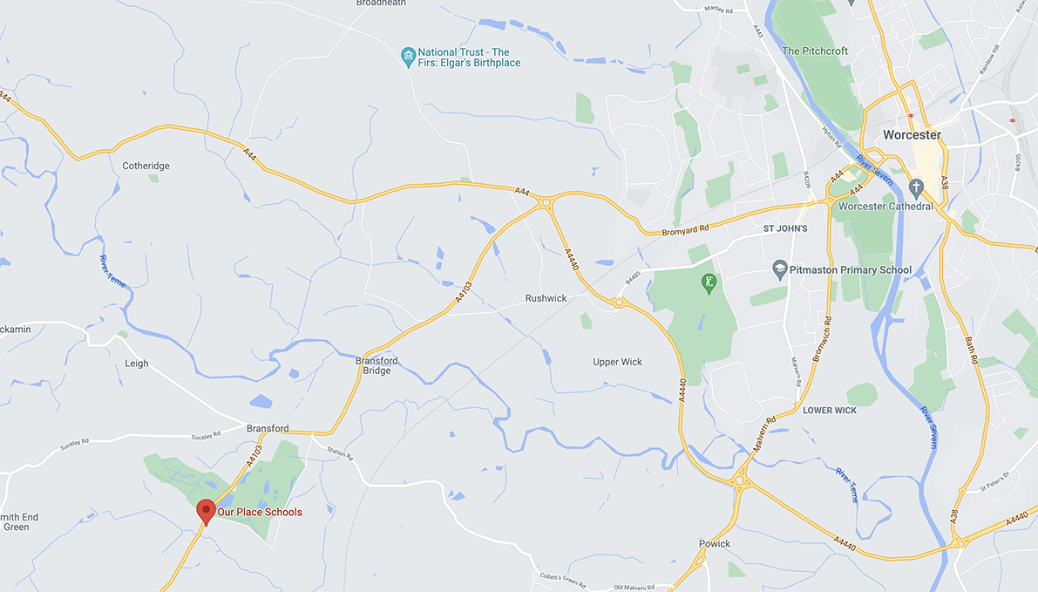

Annex A

Name | Job Title | Qualification Relevant to Role | Years of Care Experience | Gender
Leadership Team
Justine Bishop | Responsible Individual | Qualified Social Worker BA Honours In Social Worker  Level 3 Diploma in Children and Young People in the Workforce.  Level 5 in leadership and management. | 12 | F
Chris Johnson | Registered Manager | Level 3 Diploma in Children and Young People in the Workforce.  Currently completing Level 5 in leadership and management. | 10 | M
Kayleigh Campbell | Deputy Manager | NVQ Level 2 in Health and Social Care, Engaged in CPD Pathway | 2 | F
Nicholas Waller | Deputy Manager | NVQ Level 4 in Health & Social Care, Level 2 & 5 Diplomas in Health & Social Care. CPD Pathway relevant to role | 26 | M
Jasmine Thoburn | Deputy Manager | Diploma level 3.  Level 5 in Leadership and Management for Residential Childcare | 3 | F
Michelle Fidoe | Deputy Manager | Diploma 3  To be enrolled on level 5 following the completion of probation. | 4 | F
Sophie Harrison | Deputy Manager | BA in Criminology and Psychology.  BTEC National Diploma in Children | 8 | F
Stephanie Akers | Acting Up – Deputy Manager | Currently completing the Diploma level 3 | Less than 1 | F
MDT
Psychologist | Post recruited to-Starting Jan 2023
Gopal Mehra | Occupational Therapist | BTEC Health & Social Care Level 3; Occupational Therapy BSc Honours; CPD Pathway relevant to role | 3 | M
Speech & Language Therapist | Post Recruited-Starting Jan 2023
Duty managers
Jessica Eaton | Duty Manager | Level 2 Health and Social Care; CPD Pathway relevant to role | Less than 1 | F
Niamh Jeavons | Duty Manager | Enrolled on Diploma level 3.  Level 2 in Child Development | Less than 1 | F
Sophie Phillpotts | Duty Manager | Currently completing the Diploma level 3.  A Levels Health & Social Care | Less than 1 | F
Jacob Watton | Duty Manager | Currently completing the Diploma level 3.  Intermediate Level Apprenticeship in Activity Leadership: Outdoors; in the Active Leisure & Learning Sector | Less than 1 | M
Support Workers
Samantha Rudge | Support worker | BA Hons in Criminology & Criminal Justice. Level 3 Lead adult Care Workers; engaged in Diploma 3; Pathway relevant to role | 6 | F
Sarah Wofford | Support Worker | Engaged in CPD Pathway relevant to role | Less than 1 | F
Alex Jones | Support worker | To be enrolled on diploma level 3 following the completion of probation. | Less than 1 | F
Antonio Nzaba | Support worker | Currently completing the Diploma level 3  Health & Social Care Level 2 | 8 | M
Fern English | Support worker | To be enrolled on diploma level 3 following the completion of probation. | Less than 1 | F
Haleema Ahmed | Support worker | To be enrolled on diploma level 3 following the completion of probation. | Less than 1 | F
Jain Eagle | Support worker | Enrolled on Diploma level 3. | Less than 1 | F
Jaye Taylor | Support worker | Currently completing the Diploma level 3.  Care Certificate | Less than 1 | F
Joanna Tomasik | Support worker | Enrolling on Diploma level 3.  Bachelor's degree in Pedagogy - Education with Art | Less than 1 | F
Mary Baker Cooper | Support worker | To be enrolled on diploma level 3 following the completion of probation. | Less than 1 | F
Matthew Low | Support worker | Currently completing the Diploma level 3.  Level 2 Health & Social Care | Less than 1 | M
Victoria Chrzaszcz | Support worker | Currently completing the Diploma level 3.  Care Certificate | Less than 1 | F
Night staff
Claire Banner | Waking Nights Duty Manager | Nursing Diploma, GNVQ Advanced H&SC; CPD Pathway relevant to role | 14 | F
Charles Nwoko | Waking Nights Duty Manager | CPD Pathway relevant to role | 5 | M
Bijo Jose | Waking Night Deputy Duty Manager | Master of Social Work - Current Pin, England. | 18 | M
Matt Davies | Night Support Worker | Diploma in Health and Social Care, Engaged in Diploma 3; CPD Pathway relevant to role  Level 2 counselling skills; level 2 Health & Social Care | 4 | M
Henry Ezeogu | Night support worker | CPD Pathway relevant to role | Less than 1 | M
Chelsea Fleet- Tedstone | Night support worker | Level 3 Diploma | 2 | F
Mikel Stewart | Night support worker | Level 3 Diploma | 2 | M
Helen Merrick | Night Support Worker | To be enrolled on diploma level 3 following the completion of probation. | Less than 1 | M
Paige Cooling | Night Support Worker | BTEC/EC3 Health & Social Care | 2 | F
Relief Support workers
Nia Jones | Relief Support Worker | Level 3 Health and Social Care | Less than 1 | F
Keely Cooper | Relief Support Worker | Currently completing the Diploma level 3 | 4 | F
Hafsah Muminah | Relief Support Worker | BsC Counselling Psychology Honours, CPD Pathway relevant to role | Less than 1 | F

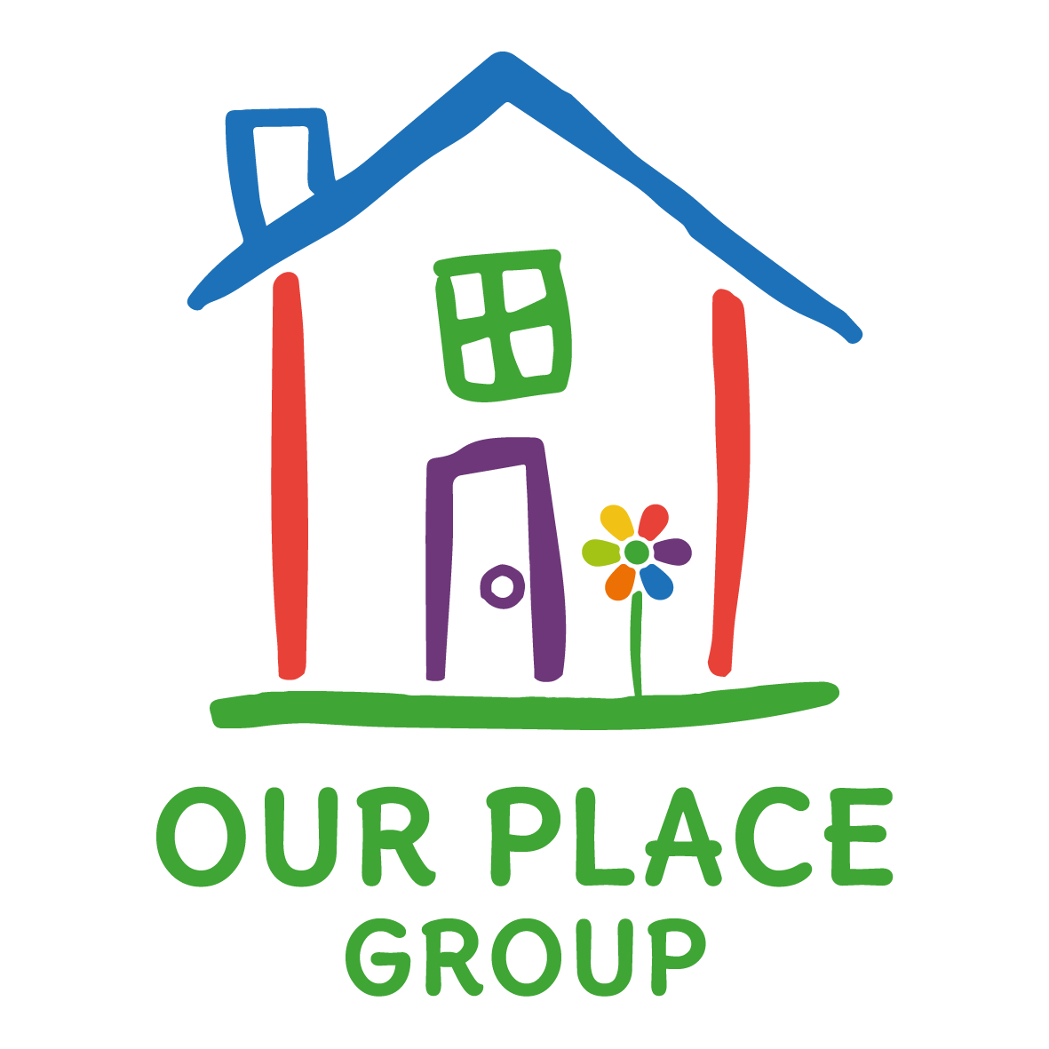

Lakeside at Our Place, The Orchard,
Bransford, Worcester WR6 5JE
t: 01886 833378
e: contactus@ourplaceschools.com
www.ourplaceschools.com

