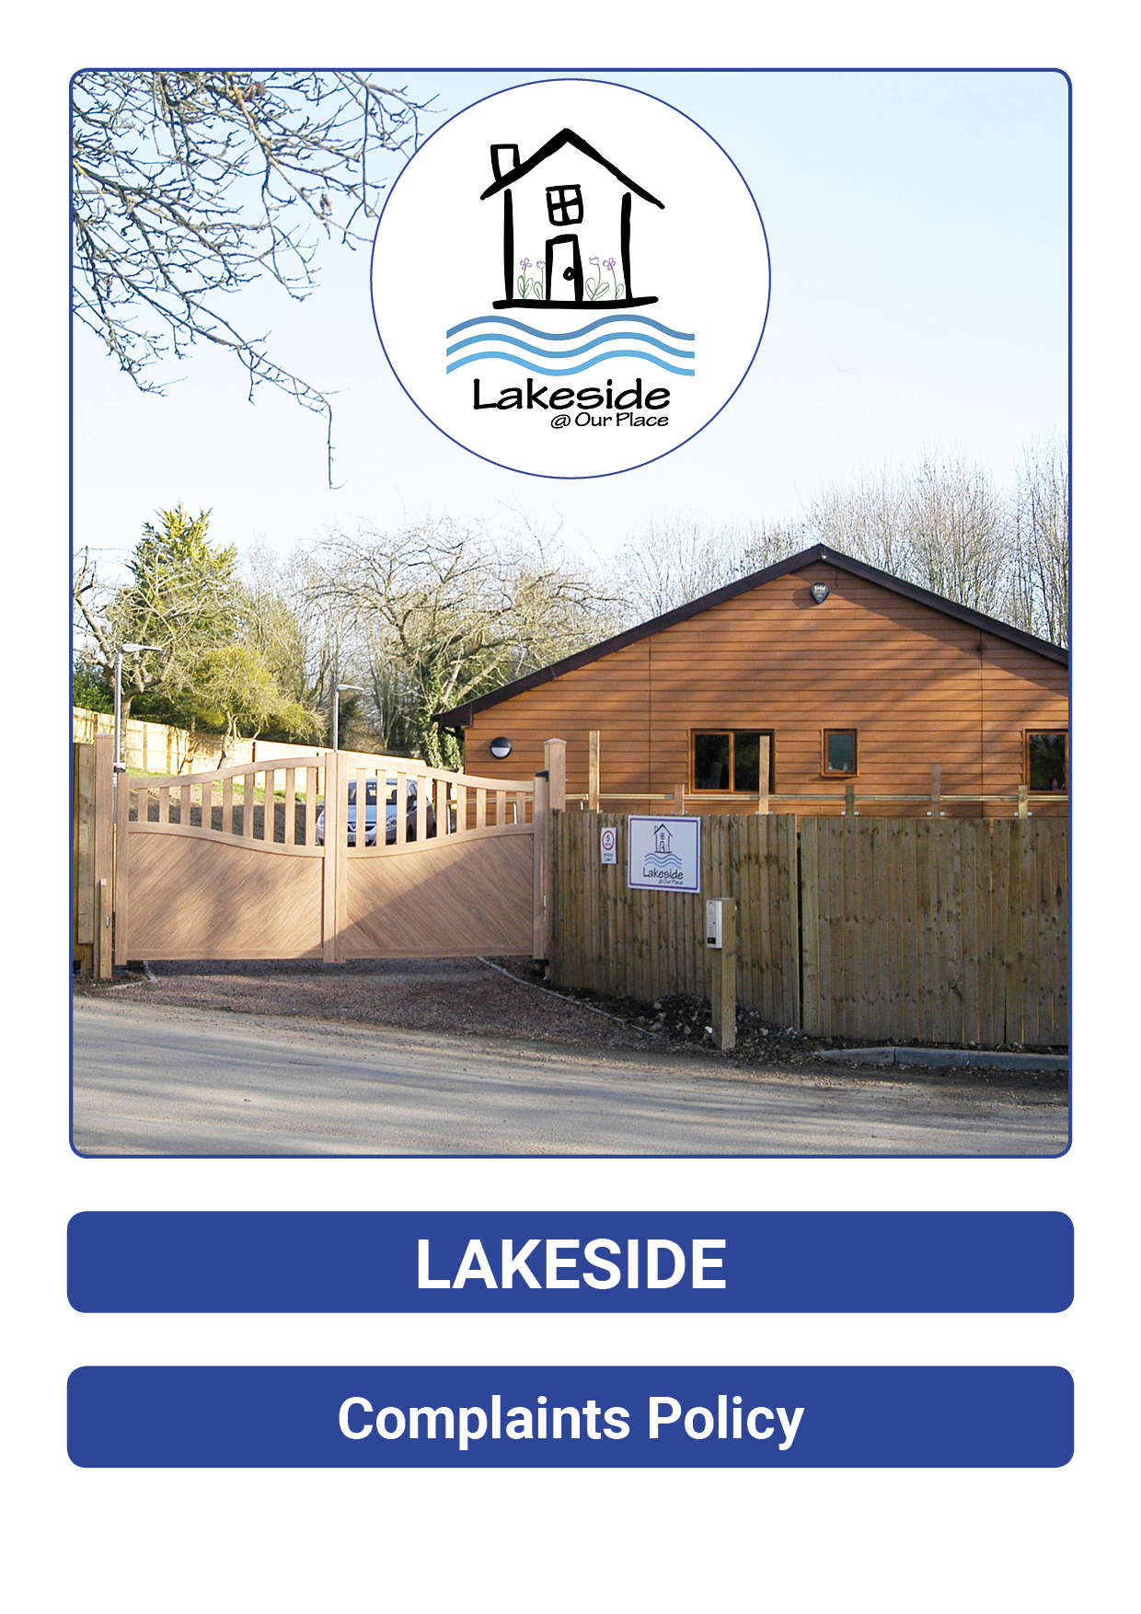

Policy Number | Version | Date | Policy Owner | Review Frequency | Review Date
LS10 | 2 | May 2021 | Daniel O Dowd | Annually | May 2022

Table of Contents

Section | Item | Page
1 | Front page, contents, review sheet | 1-3
2 | Policy statement | 4
3 | How complaints are received | 4
4 | Procedures for resolving complaints with timescales | 6
5 | Stages of complaint | 6
6 | Staff complaints about other staff (non safeguarding or pupil welfare) | 7
7 | Minor complaints | 8
8 | Serious complaints | 8
9 | Complaint about Senior Leadership Team | 8
10 | The school/ home regulators | 9
11 | Other contacts | 9
12 | APPENDIX 1- Complaint, concern, safeguarding form. | 10

Approved By | Name | Date
Registered Manager | Daniel O Dowd | May 2021

Review Sheet
The information in the table below provides details of this documents reviews, and where appropriate amendments, which will have made to later version and the reason why.

Version 1 | Review Description | Date reviewed
1 | Original | Nov 2018
2 | Updated to new format, addition flow procedures and updated contacts for external avenues. | March 2020
3 | Review | March 2021
4 | Review | May 2021

Policy Statement:

Lakeside Schools aims to provide a happy, safe and caring environment that will enable pupils to learn and communicate with confidence. This complaint’s policy is designed to allow parents (and others) to raise issues of concern/complaint with the School as set out in ‘The Independent School Standards Regulations 2014’ and the ‘Residential Special Schools National minimum standards (2015).’
However there may be times when a pupil, their parents/guardians or any other person who comes into contact with the school/home may wish to make a complaint about any aspect of the school or care home. We encourage comments from all, so that we may improve the service we deliver. We acknowledge that complaints do occur and respect those who do complain or comment and we seek to respond in a positive and open manner. There are no restrictions on the issues that a student or adult can make a complaint about.

Lakeside schools and the associated home operate within the guidelines set out in the ‘Children’s Homes (England) Regulations (2015)’ and follow the’ Guide to the Children’s Homes Regulations, including the Quality Standards’, and the ‘Independent School Registration Regulations.’ This policy is the formal written complaints procedure for the School and the Children’s home.

The policy will be available to pupils, parents and any interested person.

Complaints will be managed within the timeframes set out in this policy in the stages of complaints resolution.

How Complaints are received:

All complaints by parents/guardians, Children or any other person are to be made to a member of the School or Care Home’s staff and will be recorded as a concern and passed to a member of the management team (education or care) for response. A complainant may contact our regulator Ofsted in England and in Wales, CIW/ Estyn, directly at any time if they so wish (see contact numbers later).

A central register is kept in the home of all complaints made and monitored regularly by the School’s Senior Leadership Team.

The Senior Leadership Team decides who is best placed to investigate the complaint without bias.
Any person is entitled to make a complaint about any aspect of the Home or their experiences of it. This includes people who are not directly involved with the Home (e.g. members of the public). Their complaints or representations should initially be taken by the staff in the Home Manager and then they should proceed according to the procedures detailed within this policy.

Pupils may have difficulties with speech, language and communication. Therefore making a complaint may be a difficult task for them to manage themselves. Anyone reviewing a complaint from a pupil or advocating on their behalf should take account of these difficulties and deploy communication strategies suited to the young person’s needs as advised from SALT (speech and language therapist)

When a person needs to register a major complaint or representation, the member staff who has worked with the person or parent making a complaint will contact a member of the Senior Leadership Team at the earliest opportunity (normally within 24 hours).

The Senior Leadership Team will consider the content of the complaint and decide on action to be taken. Where a complaint involves Child Protection issues then the Designed Safeguard Lead/ Officer who is a member of the Senior Leadership Team will be responsible for informing the Local Safeguarding Board and placing authority, including notifications to Ofsted or Adult Protection Services within 24 hours of receiving the complaint. See safeguarding policies.

When a pupil wants to make a minor complaint about any aspect of school/ home, this should be dealt with by talking to the keyworker, teacher, Speech & Language Therapist (SLT), Head of Care, or, indeed, any staff member in the school/ home that is relevant. All staff have a duty of care to the pupils, and should advocate for them.

Examples of (but not limited to) minor complaints are:

- A person is unhappy with the food that s/he has been served

- A person is unhappy with the variety of after-school activities that are offered

- A person feels that the pillows that are offered are too lumpy

- That the classroom is too hot/ cold/ bright/ dark

- The young person’s bedroom has not been decorated correctly

- The soft play area is not accessible at an agreed time for the pupil

If the complaint is of a more serious nature it will be acted upon by a member of the Senior Leadership Team according to the procedures that follow. The person making a complaint also has access to outside advice and this right should be made aware to the person making a complaint by the person they are making the complaint to.

Examples of more serious complaints (these which should be referred to the Senior Leadership Team without undue delay) are:

- A student/young person or their representative believes themselves to be the target for bullying by his/her peers

- A student/ young person or their representative believes themselves to be the subject of abuse or bullying by any adult (including their home setting)

- A person feels that the content of a lesson or activity in which they were present (or had evidence of) was not fully matched to the need of a pupil

- A member of staff fails to deliver a promised commitment to a parent/ young person / external professional

At all stages, it must be made clear to the person making a complaint that there will be no reprisals against them as a result of making a complaint.

At all stages, complaints should be made in confidential surroundings and the privacy and dignity of the complainant should be protected.

A pupil who raises a complaint or representation will not be subject to any criticism or sanction for raising the complaint.

Where a pupil’s complaint is found to be malicious, this will be addressed with parents and social workers and not through any form of consequences within the school or home.

Procedures for Resolving Complaints with Timescales:

Complaints and concerns received by staff will be acted upon by that member of staff or passed on to the relevant staff for action. In either case appropriate ‘Concern, complaint or safeguarding’ form needs to be completed and the complaint recorded in the School/Home complaints record.

There are five (5) possible stages to the complaints procedure as follows:

1) Informal stage: discussion between the complainant and a member of the home’s staff. This may be a minor complaint and one which can be dealt with very quickly by the member of staff concerned. This is typically done within 5 working days.

2) Formal stage: if the complainant is not satisfied, he or she can put their complaints in writing to the Head of Care who will inform the Senior Leadership Team, who will nominate a member of staff to investigate the complaint. The person will not be the subject of the complaint, unless it is appropriate as determined by the Director.

Within 10 working days the nominated member of the Senior Leadership Team must either inform the complainant of a decision, or tell the complainant when a decision will be made.

This stage will have included consultation with the person making a complaint.

Once the complaint or representation has been resolved the nominated member of the Senior Leadership Team will write to the person making a complaint, to outline the resolution.

Where a complaint or representation takes longer than 10 working days to resolve, records showing ongoing communication with the person making a complaint should be filed with the original complaint.

Reconciliation stage:

- If the complainant remains dissatisfied, Registered Manager must try to resolve the matter. Within 10 working days, the Registered Manager must either inform the complainant of a decision, or tell the complainant when a decision will be made.

- Director non-hearing stage: If the complainant remains dissatisfied, the Head of Function will refer the issue to Lakeside Director Lena Graham.

- The Director will seek to resolve the complaint within 10 school days, or if this will take longer, inform the complainant when a decision will be made.

- If the complaint is not resolved as this stage, then the complainant will be offered a 3-person panel hearing.

The Director may choose to bypass any stages and move straight to a 3-person panel hearing at any time.

Hearing Panel stage:

If the complainant wishes the matter to be considered further, a hearing before a panel of at least 3 people who were not directly involved in previous determination at any other stages, the complaint panel will be arranged.

To that end:

a) The Director is responsible for the appointment of the panel.

b) One person on the panel will be independent of the management and running of the establishment (that is the school’s day-to-day running). Typically Lakeside will seek all panel members to be independent of the Home.

c) The complainants may attend the panel, and if so wished be accompanied, with all costs for attendance being for the complainant’s sole account; reasonable adjustments will be made under the expectations of the Equality Act 2010.

d) The panel’s chair will agree typically within 10 working days of receiving the appeal to panel, a hearing date with the complainant, subject to the complainant being contactable.

e) This hearing date will typically be within 28 working days of the date of appeal unless Safeguarding requirements necessitate that the complaints procedure is suspended until a Safeguarding matter is resolved. Once resolved, the complaints procedure timetable will restart from the time it was suspended.

f) The panel will hear the complaint and make its findings known to the complainant in writing (by way of letter or email), and where relevant the person the person complained about, typically within with 20 working days.

g) The findings and recommendations are available for inspection on the school’s premises by the Director and Registered Manager.

h) All the complaints, the outcomes and actions taken will be recorded in the schools/ home complaint log and made available for inspection on the home premises by the director, Registered Manager and regulatory authorities. They will indicate whether the complaint was resolved at the preliminary stage or preceded to a panel hearing.

i) Complaint records will be stored confidentially. They will also be made available to Ofsted.

j) The panel’s decision is final.

Staff complaints about other staff (non-safeguarding or pupil welfare issues):

Complaints from staff about other staff (i.e. grievances) will be managed through the staff complaints and grievance procedure set out in the staff handbook.

A staff complaint about the practice of another employee concerning the welfare of a pupil, parent/guardian or professional will be managed via the safeguarding procedures and/ or this complaints procedure

Minor complaints:

Minor complaints and representations made by pupils and parents in social care must be logged in ‘The Complaints Log’ kept on the home with a record of how they have been addressed.

All entries should be signed and dated by the member of staff addressing the complaint. The Complaints Log should be kept in a locked cupboard when not in use.
The central log of complaints kept for formal complaints also provides a central record of all minor complaints as well.

The Senior Leadership Team will review the contents of the Complaints Log on a regular rolling basis as part of quality assurance. Where there are inaccuracies or discrepancies discovered by the Senior Leadership Team, this will be investigated for the cause of the inaccuracies or discrepancies.

More serious complaints and representations will be addressed and will be acted upon by, the Senior Leadership Team.

These will be made and recorded using the Lakeside formal documentation.

It is not generally expected that a pupil will complete documentation as an advocate is available to do this for them. However where a pupil particularly wishes to complete their own documentation, they should be provided with the appropriate documentation and means to do so.

Serious Complaints:

Examples of very serious complaints may be:

- A person believes that a member of staff has abused their position with pupils – THIS IS SAFEGAURDING!

- A person believes that an act of abuse (in whatever form) has been perpetrated by a staff member – THIS IS SAFEGAURDING!

Where an issue of safeguarding is raised, then Lakeside Home will raise the issue through the safeguarding policy first, before addressing the complaint.

Complaints about the Senior Leadership Team:

Complaints and representations about the heads of Function and/ or the Senior Leadership Team should be made directly to Lakeside Executive Director Mr David French; he can be contacted as follows:

Email: director@ourplaceschools.com or 01886 833378

In Writing Lakeside, The Orchard, Bransford, Worcestershire, WR6 5JE

The School/ Home Regulators:

The School and Home’s regulator is Ofsted.
They can be contacted directly as follows:

Ofsted
Piccadilly Gate
Store Street
Manchester
M1 2WD
enquiries@ofsted.gov.uk or 0300 123 466

Other contacts:

The telephone numbers of outside agencies which can help pupils are displayed around the school/ home and are as follows:

Childline (run by NSPCC) 0800 11 11

NSPCC help for adults 0800 800 500

The Office of the Children’s Commissioner:
Phone- 0880 528 0731
Email- help.team@childrenscommissioner.gov.uk

Reg 44: Independent person
Contact via Lakeside Schools

Accessible formats of this policy are available upon request.

APPENDIX 1- Complaint, concern, safeguarding form – Lakeside @ Our Place

Complaint | Concern | Safeguarding

Your Name & position:
What is your complaint:

Date and Time of your complaint:
Date & name of person you first reported this complaint to:
Name of pupils / person involved & how they were involved:
Name of adults involved and detail of their involvement:

Detail of any action taken & by who:
Detail of any documentation linked to this complaint you are aware of:
Other information you believe is relevant:

Your signature:
Response time note *Complete only by Manager receiving document

No Action | Up to 48 hours | Up to 5 days | Up to 10 days | Up to 28 days

Phase 2. To be completed by the person receiving complaint (notification, action, document amendment)

Date/Time | Events- Meeting/Observation/Contact | Supporting  Documentation | Staff  Initials

Name of Person leading complaint/Safeguarding (DSL)
Date Received

Conclusion of Complaint, concern or Safeguarding

Phase 3. Resolution
Decision made / outcome | Who made the decision

Guidance, support and feedback (Learning Outcome)

Date closed | Name & Signature
Copy on *young person’s file, *employee’s file, homes records *as required*

